**FLEXMONEY ASSIGNMENT**

**FRONTEND -**  React Js, CSS

**DATABASE -** MySQL

**BACKEND -** Java, Spring Boot

**SCREEN - 1 HOME PAGE**



**SCREEN - 2 REGISTER PAGE**

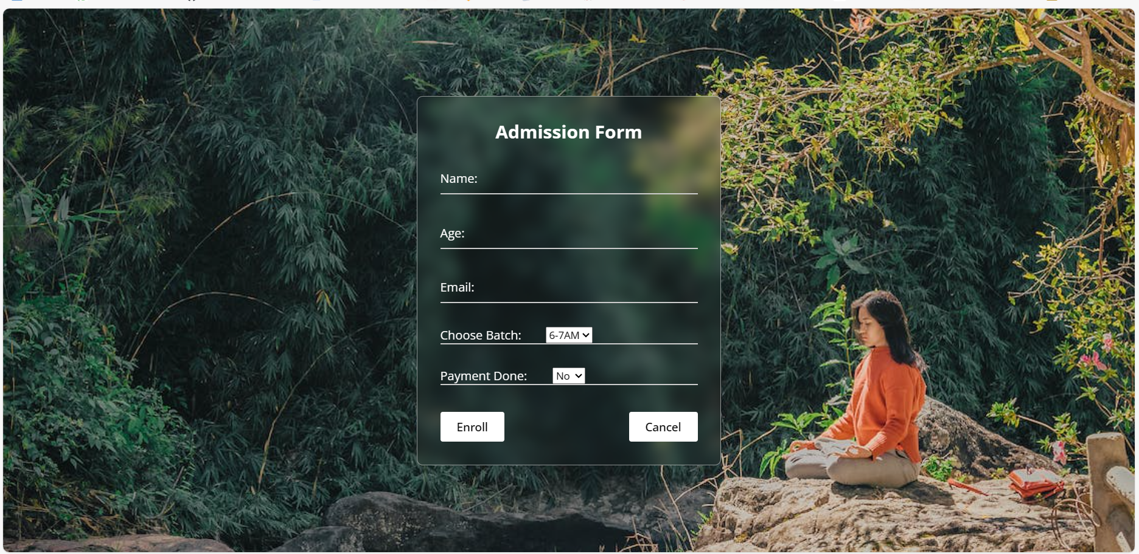

**WORKFLOW DIAGRAM**

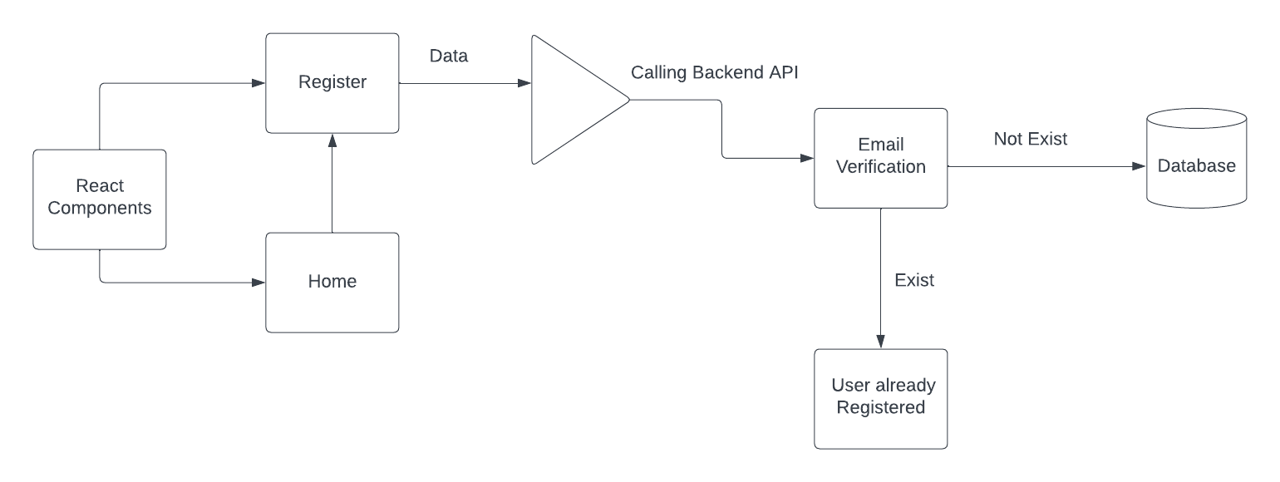

User after filling the required fields ( Name, Age, EmailId, Batch Timing, Fees) hits the

Enroll button which converts the required fields into JSON format.

Then, it calls the backend API along with the JSON data. It further checks whether the

entered emailId already exists in the DATABASE or not.

If the emailId does not exist then it calls the CompletePayment method in the backend

and based on the value of PaymentDone it sets the value of Total Fees.

If PaymentDone is Yes, then it sets the value of Total Fees to 500 else it sets the value

to 0.

If the emailId exist in the DATABASE then it returns a message to the frontend, that

This emailId already exist which is displayed to the user at the frontend side.